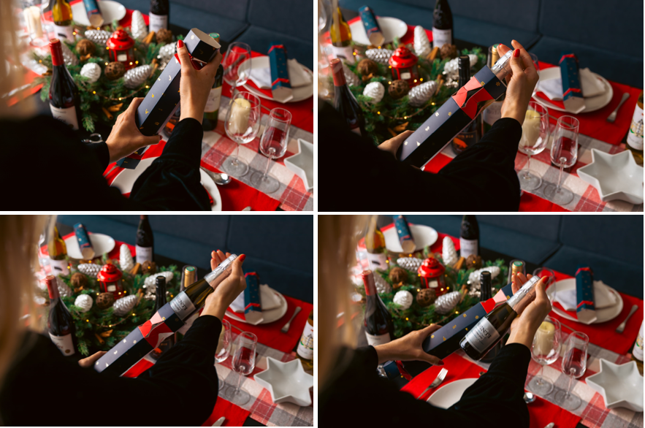
Virgin Wines launch drink-filled Christmas Crackers
Virgin Wines’ alcohol-filled Christmas crackers are back and ready to make this year’s festivities go off with a bang.
This December select from a set of mixed wines, prosecco, gin & tonic or mixed spirits crackers to bring a little extra joy to celebrations.
The addition of quality alcoholic drinks doesn’t mean forgoing tradition, each cracker also contains a classically festive paper hat and cheesy joke.
Crackers come in packs of six and highlights include bottles of Virgin Wines’ exclusive red and white wines and best-selling Senti Prosecco - all of which are carefully made by independent winemakers. In the G&T crackers, there’s 50ml (double shot) bottles of six different gins, including a taste of Christmas with The Henley Distillery Gingerbread Gin. The mixed spirits crackers contain all the classics, from whisky and vodka to gin and rum.
Prices are as follows: Prosecco Crackers (£32.99), Mixed Wine Crackers (£31.99) Gin & Tonic Crackers (£34.99), Mixed Spirits Crackers (£34.99).
Download high-res images
On sale from December 1st.
Alcohol Christmas Crackers 2023 | Wine, Prosecco & Gin Crackers | Virgin Wines
www.virginwines.co.uk
ENDS
For further information please contact:
Emily Revell
PR, Purpose & Sustainability Manager
Virgin Wines
T: 01603 886618
E: Emily.revell@virginwines.co.uk
Notes to editors:
Virgin Wines is one of the UK’s largest direct-to-consumer online wine retailers. More than 90% of its wines by volume are exclusive and during 2020 the company delivered over one million cases to its customers. The company also sells a growing range of beers and spirits as well as having an industry leading gift service and a thriving corporate sales department.

It is a multi-award-winning business with a reputation for curating and supplying high quality products, excellent levels of customer service and innovative ways of retailing.

https://www.virginwinesplc.co.uk/
https://www.virginwines.co.uk/

