Virgin Wines join the Sustainable Wine Roundtable
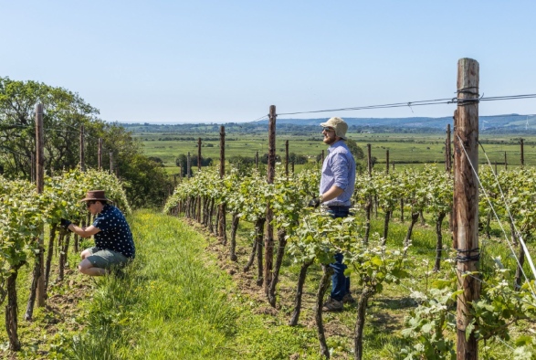
One the UK’s largest direct-to-consumer online wine retailers, Virgin Wines, is delighted to share that it’s become a member of the Sustainable Wine Roundtable (SWR).
SWR is the only global collaborative platform to advance sustainability across the wine industry from production to retail. Virgin Wines is pleased to be joining its peers at the roundtable and working towards the collective goal of advancing sustainable impact through best practice sharing and collaborative initiatives.
CEO Jay Wright says: “Becoming part of the Sustainable Wine Roundtable is an important step for us as we continue to develop our long-term strategy in terms of sustainability. We want to do what’s best for the industry as a whole, and we’re proud to be joining a group that are collaboratively working towards that shared goal.”
Tom Owtram, General Manager of the SWR commented "We are delighted to welcome Virgin Wines to our global membership of more than 90 members. The SWR brings together leading wine companies from across the value chain to collaborate and drive collective action and knowledge sharing. It's an exciting time to join the organisation as we look to grow our impact at scale".
www.virginwines.co.uk
ENDS
For further information please contact:
Emily Revell
PR and Outreach Manager
Virgin Wines
T: 01603 886618
E: Emily.revell@virginwines.co.uk
Notes to editors:
Virgin Wines is one of the UK’s largest direct-to-consumer online wine retailers. More than 90% of its wines by volume are exclusive and during 2020 the company delivered over one million cases to its customers. The company also sells a growing range of beers and spirits as well as having an industry leading gift service and a thriving corporate sales department.

It is a multi-award-winning business with a reputation for curating and supplying high quality products, excellent levels of customer service and innovative ways of retailing.

https://www.virginwinesplc.co.uk/
https://www.virginwines.co.uk/

