Fit for a King: Virgin Wines release Coronation English Sparkling Brut
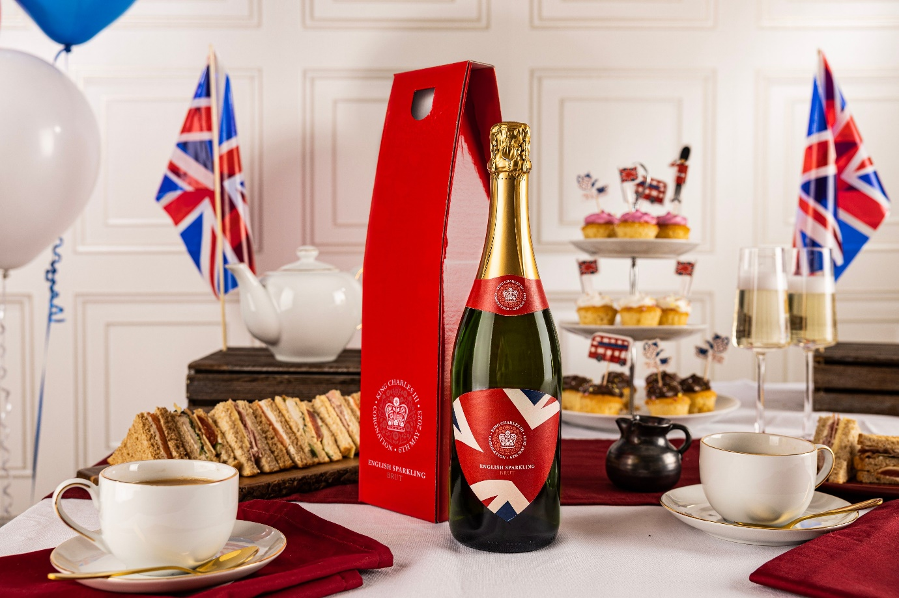
Virgin Wines are celebrating the coronation of King Charles the only way they know how, with a special commemorative sparkling brut that’s been lovingly handcrafted in Sussex, the jewel in the crown of English winemaking.
Hang up the bunting and raise a glass of sparkling fit for royalty in honour of the newly crowned King on Saturday 6th May. This limited-edition bottle comes from Henners, a charming coastal vineyard nestled in the South Downs in Sussex, bringing a stylish brut with all the pizzazz of Champagne and elegance of the English countryside.
A traditionally fermented cuvée of Chardonnay and Pinot Noir, the commemorative coronation wine is perfectly poised (as one would expect), balancing richness and weight with freshness and grace. Expect a plush palate of apple, lemon zest, spice and toasted, buttered brioche.
Sophie Lord, Head of Buying at Virgin Wines says: “The team at Henners are masters of their craft, which is why we love working with them on special occasion projects such as this where expectations are high. Their location in Sussex is another indicator of quality, with the area being the first in England to achieve official PDO status, elevating it from a region to a protected appellation. You could say that sparkling wine from Sussex is the king of British bubbly.”
The Coronation Limited Edition English Sparkling Brut is available exclusively at Virgin Wines.
Image: Coronation Limited Edition English Sparkling Brut (£34.99)
Coronation Limited Edition English Sparkling Brut | Virgin Wines
ENDS
For further information please contact:
Emily Revell
PR, Purpose & Sustainability Manager
Virgin Wines
T: 01603 886618
E: Emily.revell@virginwines.co.uk
Notes to editors:
Virgin Wines is one of the UK’s largest direct-to-consumer online wine retailers. More than 90% of its wines by volume are exclusive and during 2020 the company delivered over one million cases to its customers. The company also sells a growing range of beers and spirits as well as having an industry leading gift service and a thriving corporate sales department.

It is a multi-award-winning business with a reputation for curating and supplying high quality products, excellent levels of customer service and innovative ways of retailing.

https://www.virginwinesplc.co.uk/
https://www.virginwines.co.uk/

