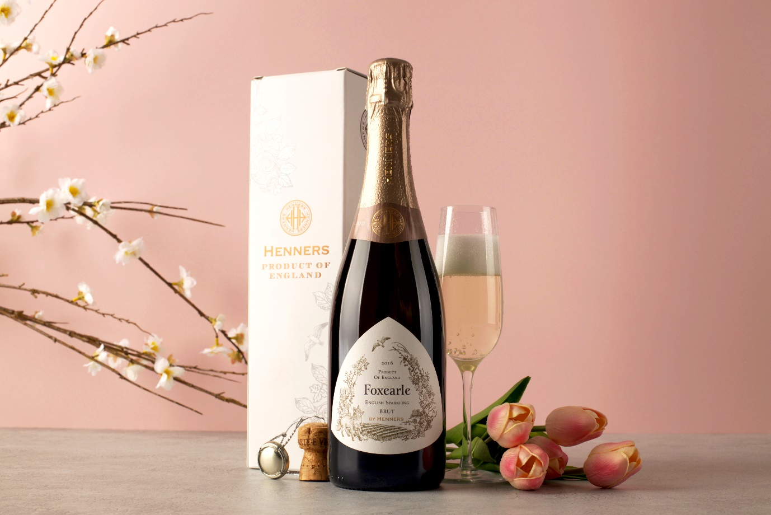
A Mother’s Day gift to remember…
Treat mum to a little luxury this Mother’s Day with a bottle of sparkling from the new and prestigious Protected Designation of Origin, Sussex. Much how Champagne can only be called Champagne if it’s from the Champagne region of France, Sussex has recently been given the same accolade, making wines produced in the county extra special.
Henners Foxearle English Sparkling Brut 2016 is a one-of-a-kind vintage sparkling from a small coastal vineyard in the village of Herstmonceux in East Sussex. It takes its name and design from the local countryside - Foxearle was the name of the medieval county in which the vineyards lie, and the label celebrates that ancient shire’s name with an illustration of a proud fox, many of which still pounce amongst Henners’ vines.
Vintage wines only get made in the best years, which makes this wine totally unique and a cut above non-vintage bubbly. It’s so special that only 5,000 bottles were made. Created by a small three-person team, Collette, Will and Samantha are involved in every aspect of this wine’s production, from grape to glass. Each bottle will have been handled by the team multiple times, as they ensure oversight on every element.
Made using the traditional Champagne grape combination and method, this homegrown take on the world’s iconic fizz, is packed full of flavours like toasted, buttered brioche, slices of fresh red apple and lemon nougat.
Henners Foxearle also took home the Best of British in the Sparkling Category at the Woman & Home Wine Awards 2022.
Image: Henners Foxearle English Sparkling Brut 2016 in Gift Box (£39.99)
Link to buy: Henners Foxearle English Sparkling Brut | Virgin Wines

www.virginwines.co.uk
ENDS
For further information please contact:
Emily Revell
PR and Outreach Manager
Virgin Wines
T: 01603 886618
E: Emily.revell@virginwines.co.uk
Notes to editors:
Virgin Wines is one of the UK’s largest direct-to-consumer online wine retailers. More than 90% of its wines by volume are exclusive and during 2020 the company delivered over one million cases to its customers. The company also sells a growing range of beers and spirits as well as having an industry leading gift service and a thriving corporate sales department.

It is a multi-award-winning business with a reputation for curating and supplying high quality products, excellent levels of customer service and innovative ways of retailing.

https://www.virginwinesplc.co.uk/
https://www.virginwines.co.uk/

