Virgin Wines becomes first online wine retailer to be certified Carbon Neutral
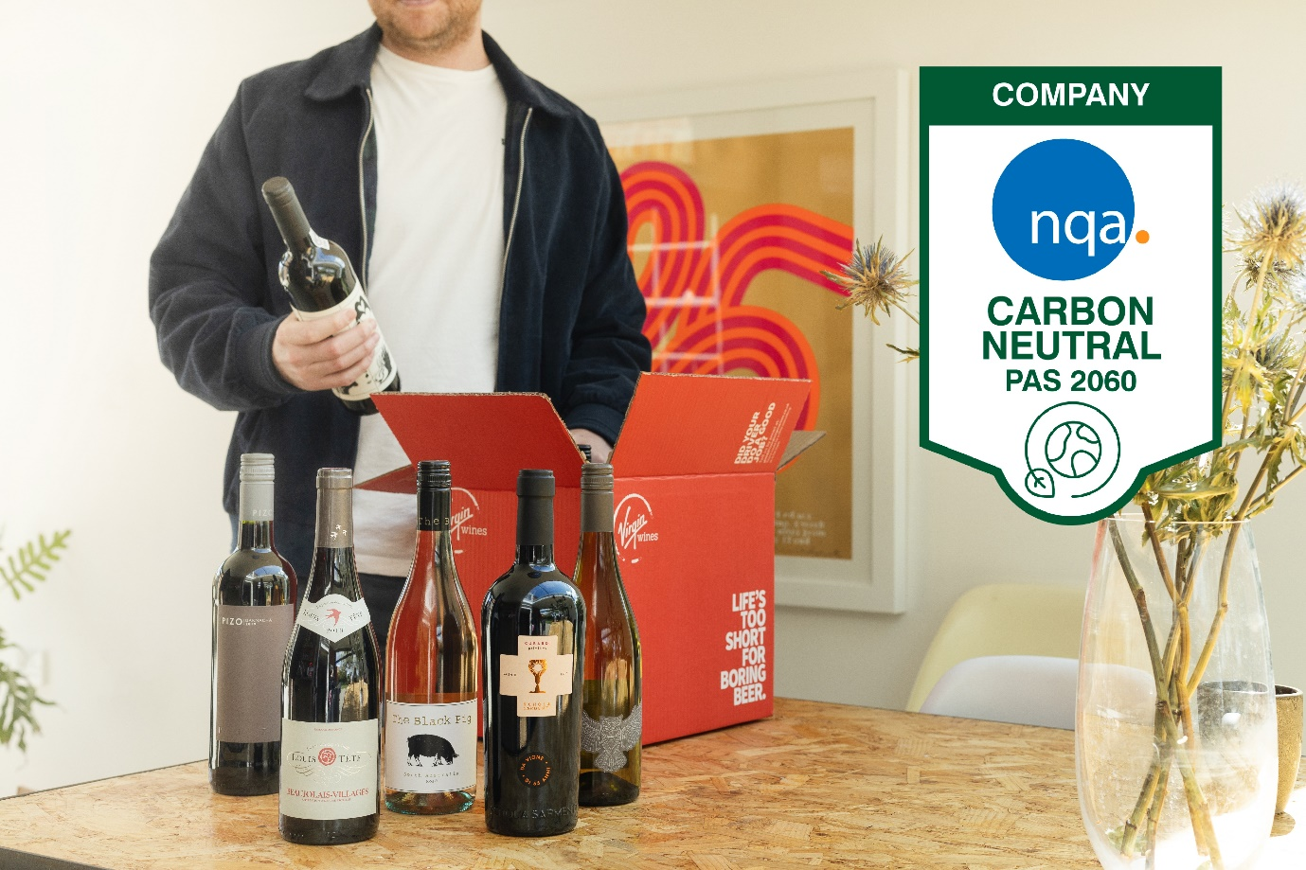Virgin Wines have been officially certified Carbon Neutral and are the first online wine retailer to achieve this status.
The online drinks retailer now holds the PAS 2060 standard, an internationally recognised standard designed to help companies achieve true carbon neutrality, following a period of external verification during the recent summer months.
Jay Wright, CEO at Virgin Wines, said: “We’re very proud to be announcing that we’ve achieved the PAS 2060 standard meaning we are now certified Carbon Neutral. While our focus is on creating great quality wines, we also want to have a positive impact on our planet and meet customers’ desires to shop with more sustainable businesses.”
Long-term, the online drinks retailer has also announced a goal of becoming Net Zero by 2045. Wright adds: “Whilst being a carbon neutral business is a fantastic achievement, we understand that this is only the first step within our journey to reduce our carbon emissions, and we’re pleased to share our goal of becoming Net Zero by 2045.”
Virgin Wines have recently applied to the Science Based Target initiative, an organisation focused on mobilising the private sector to take urgent climate change action. As part of their application, the online drinks retailer plans to cut their Scope 1 and 2 emissions by at least 42% by 2030.
Virgin Wines will be reporting on sustainability progress on annual basis going forward.
www.virginwines.co.uk
ENDS
For further information please contact:
Emily Revell
PR and Outreach Manager
Virgin Wines
T: 01603 886618
E: Emily.revell@virginwines.co.uk
Notes to editors:
Virgin Wines is one of the UK’s largest direct-to-consumer online wine retailers. More than 90% of its wines by volume are exclusive and during 2020 the company delivered over one million cases to its customers. The company also sells a growing range of beers and spirits as well as having an industry leading gift service and a thriving corporate sales department.

It is a multi-award-winning business with a reputation for curating and supplying high quality products, excellent levels of customer service and innovative ways of retailing.

https://www.virginwinesplc.co.uk/
https://www.virginwines.co.uk/

