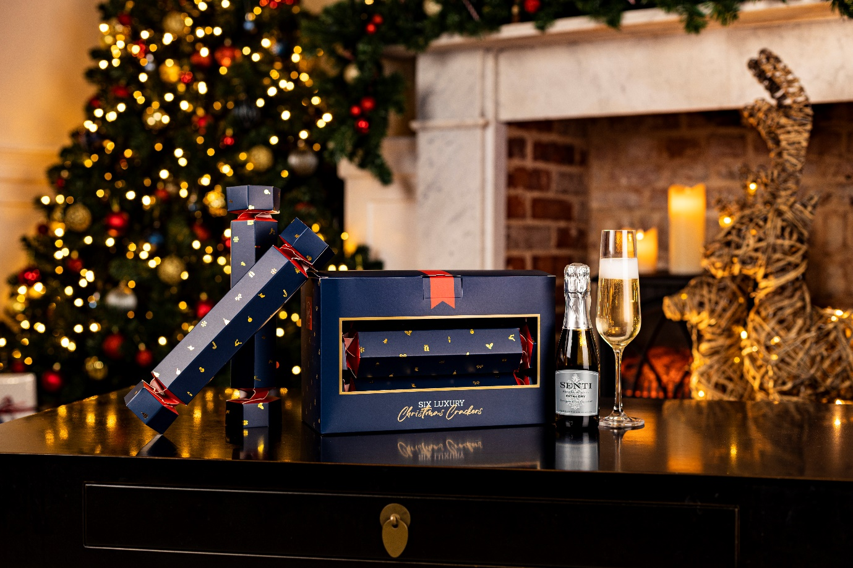
Get cracking this Christmas!
Virgin Wines’ drink-filled Christmas crackers are back and ready to make this year’s festivities go off with a bang.
This December select from a set of wine, prosecco, gin & tonic or mixed spirits crackers to spice up celebrations. Crackers come in packs of six and the addition of quality alcoholic drinks doesn’t mean forgoing tradition, each cracker also contains a classically festive paper hat and cheesy joke.
Cracker highlights include bottles of Virgin Wines’ exclusive wines and prosecco - all of which are carefully made by independent winemakers, some of which have even been dressed up in special festive labels. In the gin & tonic box, there’s classic crowd-pleasers Cotswolds Dry Gin and English Heritage Organic Dry Gin, and new for 2022, the mixed spirits crackers contain all the classics, from whisky and cognac to vodka and rum.
Prices are as follows: Prosecco Crackers (£36.99), Mixed Wine Crackers (£35.99), Gin & Tonic Crackers (£37.99), Mixed Spirits Crackers (£39.99).
Image: Prosecco Crackers.
Download high-res images (including cut-out and lifestyles).
Click here to pre-order.
www.virginwines.co.uk
ENDS
For further information please contact:
Emily Revell
PR and Outreach Manager
Virgin Wines
T: 01603 886618
E: Emily.revell@virginwines.co.uk
Notes to editors:
Virgin Wines is one of the UK’s largest direct-to-consumer online wine retailers. More than 90% of its wines by volume are exclusive and during 2020 the company delivered over one million cases to its customers. The company also sells a growing range of beers and spirits as well as having an industry leading gift service and a thriving corporate sales department.

It is a multi-award-winning business with a reputation for curating and supplying high quality products, excellent levels of customer service and innovative ways of retailing.

https://www.virginwinesplc.co.uk/
https://www.virginwines.co.uk/

