Virgin Wines see 51% rise in sales of vegan wines in last two years
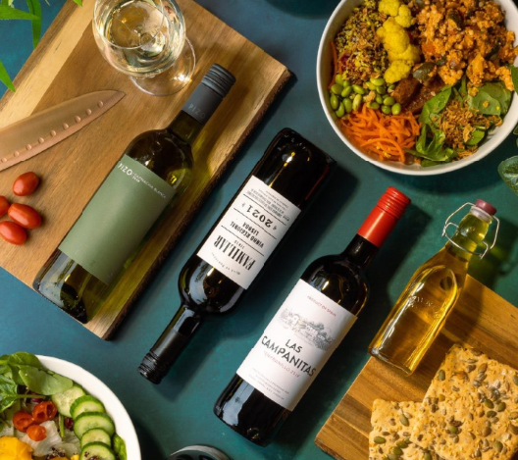

Sales of vegan wine have increased by 51% in the last two years, according to data released from Virgin Wines.
The online retailer has an extensive collection of over 400 vegan wines sourced from independent winemakers. Demand for its vegan wines has shot up, with a 51% rise in sales between 2019 and 2021.
Sophie Lord, Virgin Wines’ Head of Buying, commented: “It’s not surprising to see such a rise in vegan wine sales. Over the last decade, far more alternative wine fining methods have been found, allowing winemakers to move away from the traditional methods that are unsuitable for vegans.
“Demand for vegan, organic and biodynamic wines has grown as more consumers adopt eco-conscious and healthier lifestyles. It’s great to see that the desire for top-quality vegan-friendly wines is growing so strongly and we have every reason to believe that this will only continue.”
Virgin Wines sold 1,149,869 bottles of vegan wine in 2019 compared to 1,735,730 bottles in 2021.

ENDS
For further information please contact:
Emily Revell
PR and Outreach Manager
Virgin Wines
T: 01603 886618
E: Emily.revell@virginwines.co.uk
Notes to editors:
Virgin Wines is one of the UK’s largest direct-to-consumer online wine retailers. More than 90% of its wines by volume are exclusive and during 2020 the company delivered over one million cases to its customers. The company also sells a growing range of beers and spirits as well as having an industry leading gift service and a thriving corporate sales department.

It is a multi-award-winning business with a reputation for curating and supplying high quality products, excellent levels of customer service and innovative ways of retailing.

https://www.virginwinesplc.co.uk/
https://www.virginwines.co.uk/

